PHASE 5 – Email Notification And Flow Activation
Activity 1: Configure Email Notification
After the ticket has been automatically classified, configure Flow Designer to send a confirmation email to the caller.
- After the classification actions, click Action.
- Select Send Email.
- Configure the email details:
  - To: Caller → Email
  - Subject: Your Request for the Issue Has Been Submitted
  - Body: Enter a suitable ticket confirmation message.
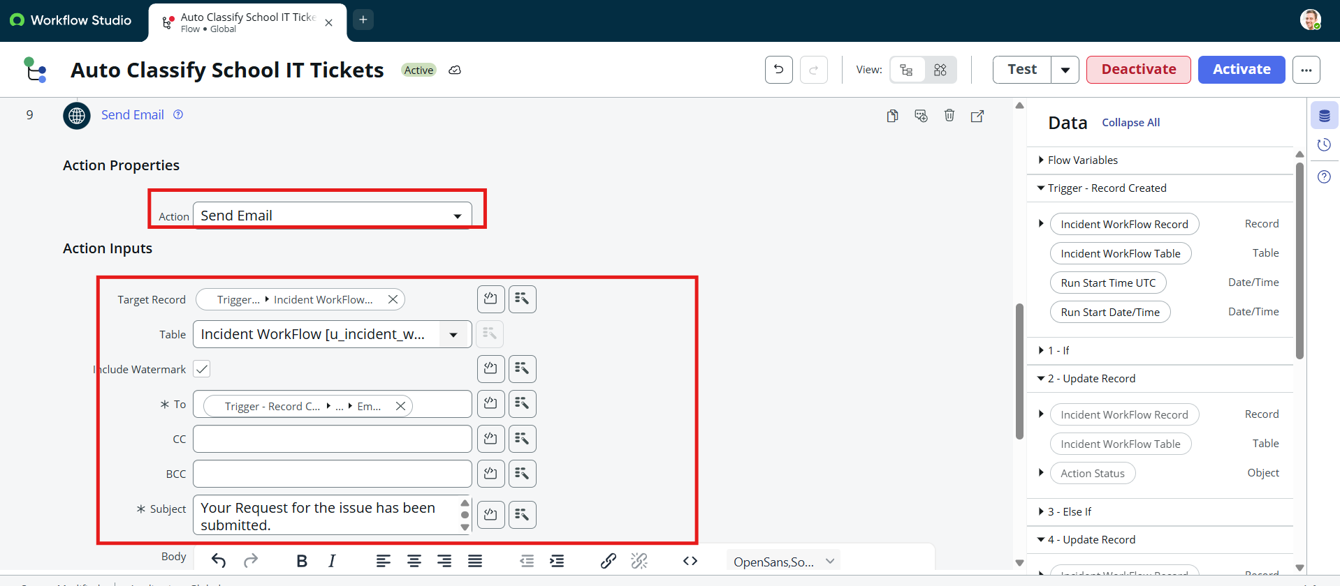
- Click Done.
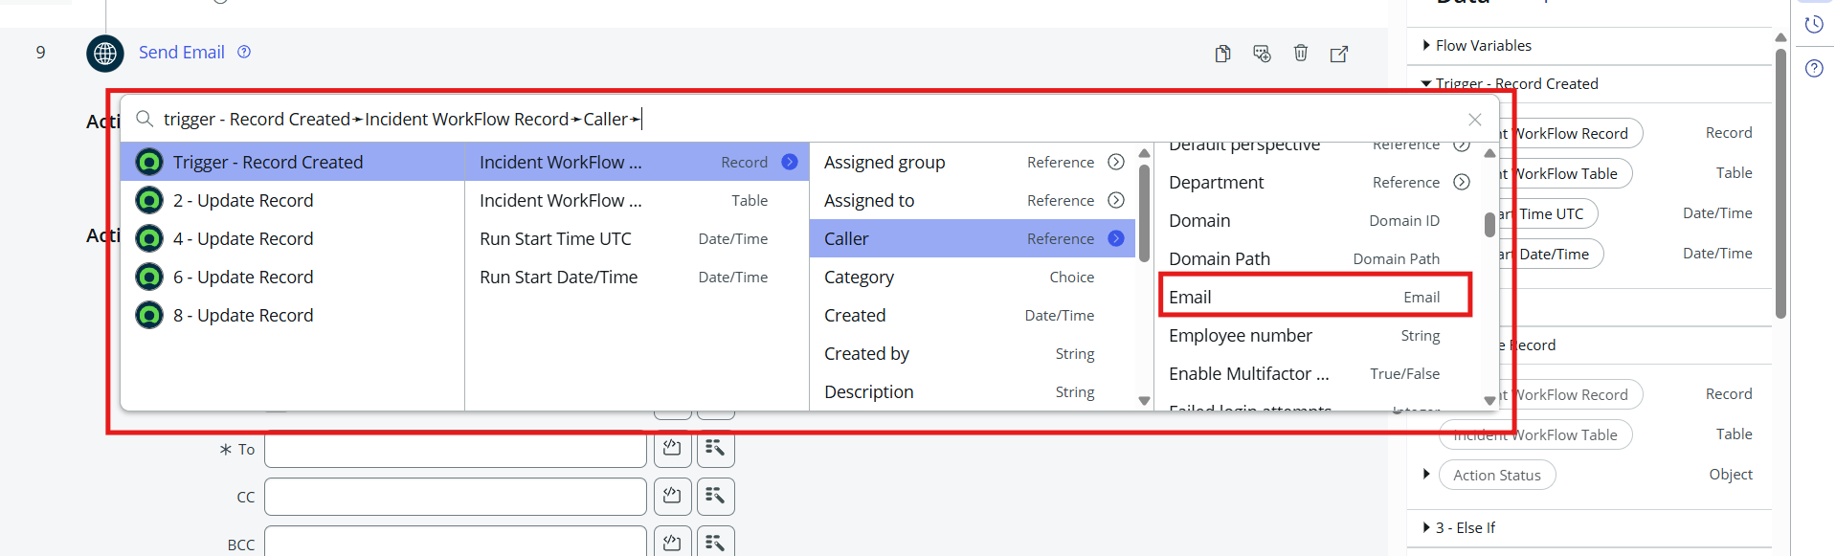

Activate the Flow
- Review all the conditions and actions in the flow.
- Make sure the keyword classification and email notification are configured correctly.
- Click the Activate button in the top-right corner.
- The flow is now active and ready to automatically classify new IT support tickets and send confirmation emails.
Expected Result
When a student creates a new IT support ticket, the flow checks the Short Description, identifies the relevant keyword, automatically sets the Category and Subcategory, and sends a confirmation email to the caller.

